**WEB DESIGN**

**PROJECT REPORT**

|  |  |
| --- | --- |
| **PROJECT TEAM** | |
| **Student No.** | **Student Names** |
| **~~16136632~~** | **~~Fabien Heinen~~** |
| **16137981** | **Ray O'Connor** |
| **16135067** | **Heino Vakkilainen** |

**Art-portfolio-site**

**\*\* Insert Project URL Here \*\***

**\*\*\*\* This section should be completed BEFORE coding begins \*\*\*\***

**Section 1: Design**

# PROJECT PROPOSAL

## Project Overview

** This section should introduce your website, outlining the early ideas or plans you have for your project and the scope of what you wish to achieve at this stage in development. **

The Client

The client (Mary Coleman) is an established Irish artist with a local following and a low level International profile. She has approached us with a view to allowing new audiences around the world access her art and get information about her work. Also, she is keen to use the site as a channel for art buyers to commission custom art and reproductions.

A self-described 'techno-phobe' she is happy to leave most of the design decisions to us however she is very clear that she favours an unfussy layout that brings the artwork to the fore. The design should be flexible enough to allow additional content to be added easily. The possibility of displaying the website on multiple screen sizes was mentioned.

The plan is to create web experience that has a a classy layout and with minimalist design elements draws the attention on the art of our fictatious designer. We will look over design elements of other sites and ncorporate the best parts. The emphasis should always be on the art and the rest should be non-obtrusive. Any Java elements or programming desicion should work in the background and not cause users to notice too much. The javascript interaction should not be adequately and not overly used, as the function should not over power the art items.

The site would consist of 5 pages, that have the same header and footer for ease of navigation.

Header would have logo on the right top corner, and links to the sub-pages. All pages should use same header to simplify design and make the experience standard.

Footer would have links to social media and contact details and as with header be standard accross all pages.

## Research / Investigation

**\*\* NOTE:** You should look at a **minimum of 3 competitors**, giving details of which companies you looked at.

This section should give details of all research carried out. What other types of websites are online targeted at your market? What do you like/dislike about these sites? How can your team better approach your own webite, having looked at the competitors. What ideas/concepts came from the research? Etc. **

We reviewed a number of art portfolio sites and fine art auctioneer sites to help us refine our design and test assumptions against existing implementations. Here are 3 sites that we used as an inspiration for the design of our site. Our design contains elements of all these websites.

### James Adam Fine Art Auctioneers [http://www.adams.ie](http://www.adams.ie/)

A very polished and professional website. Displays catalogues of fine art and antiques in grid or list view. Contains many modern web design features like; image transitions, opaque navbar, slideshow carousel widget and consistent look and feel.

We would like to borrow some elements of this website, particularly the smooth image transitions. It was decided not to implement the design based this website wholesale as it is more suited for a corporate entity. This website would be much more content heavy than our proposed site

### 1.2.2 WIX.com Website Templates for Artists <http://www.wix.com/blog/2013/05/outstanding-art-portfolios/>

There are many online applications that provide easy to customize templates for business owners without the time or inclination to design or create their own website. Some of these websites are excellent. However we feel by creating our own website by hand we can offer something that will stick out while being flexible enough to work with new content.

### Studio Anja <https://www.studioanja.com/>

This site impresses for it's simple layout and quirky art. It portrays the artists style and personality very well. We feel this site matches with our client expectations closely. The aim would be to match and exceed this site design and implementation. We also want to include more technically sophisticated elements that would allow prospective customer to engage with our client effectively ie responsive forms, interactive exhibition information, responsive slideshow etc.

We also looked at the following pages but decided to not use the elements.

1. <https://www.saatchiart.com/artschool> was not useable at all.
2. <http://www.art.co.uk> but it was much too busy

## Requirements & Technical Approach

** This section should outline what requirements that project has and how you initially plan to approach project development, taking these requirements into consideration. **

The site should work on commonly used browser: Chrome, Edge (IE), Safari, Firefox. We would work to ensure the pages are quick to load.

We would avoid certain colours for people with deuteranomaly and protanomaly (red-green colour blind) with limited usage of reds, greens, browns, oranges blue and purple hues. Except in the art item themselves of course. Font must be classy, easy to read and not too small due to the fact that the average age of our customers would be in the late 40's

The art Items would be sourced from free sources, and not created as part of the project.

We would work as a team using GitHub and Balsamiq.

# WIREFRAME / SITEMAP

** Include wireframe, and sitemap, for your website here, including brief explanations where needed, etc. **

## Header and footer

Standard across all pages in our portfolio. Simple Java script of date.

## Home Page

This is the landing page for the website. It is very important for making the first impression that we want. The home page will implement an image transition element that iterates throughout all of the art images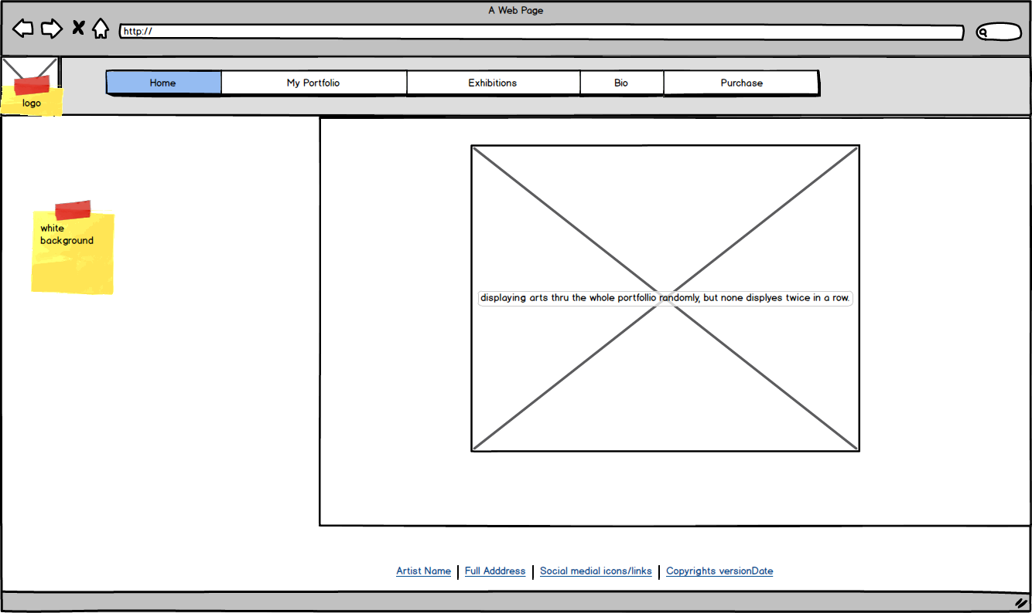 randomly.

## My Portfolio

This is the page for showcasing all of the client's art work. Allow the user to filter artwork by type (landscape, portrait), media type ( acrylic, watercolour, oil on canvas etc).

Implement slideshow capability when image is selected.

Java script to make choices

Java script slideshow.

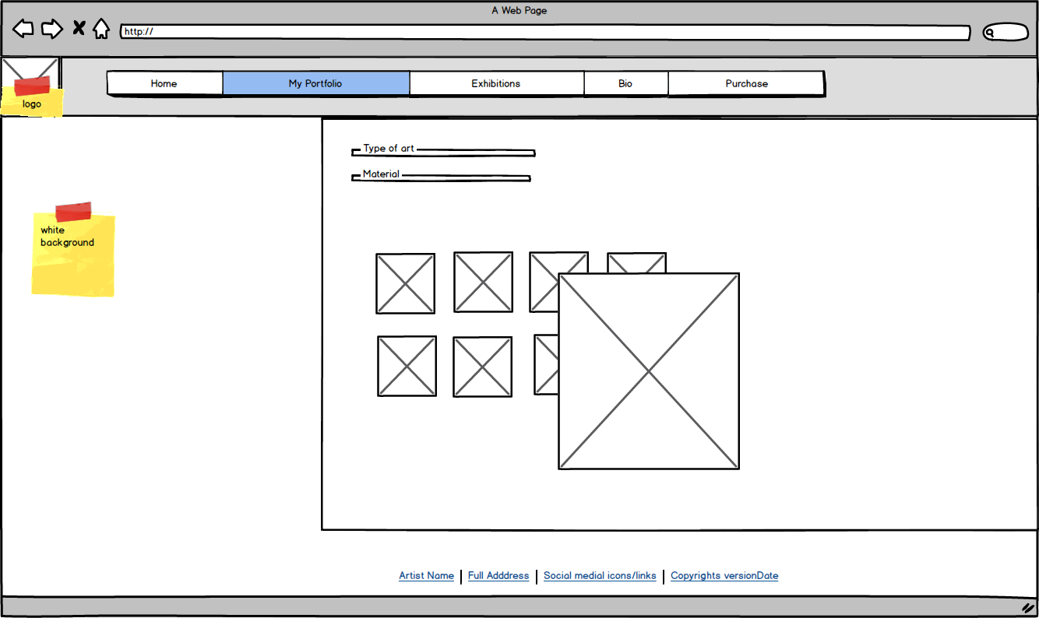

## Exhibitions Page

Display information about the client's upcoming exhibitions. Include information like:

* Date
* Location
* Time
* Name of exhibition

Embed Google Maps widget for easy location finding.

Java script to grey out past events.

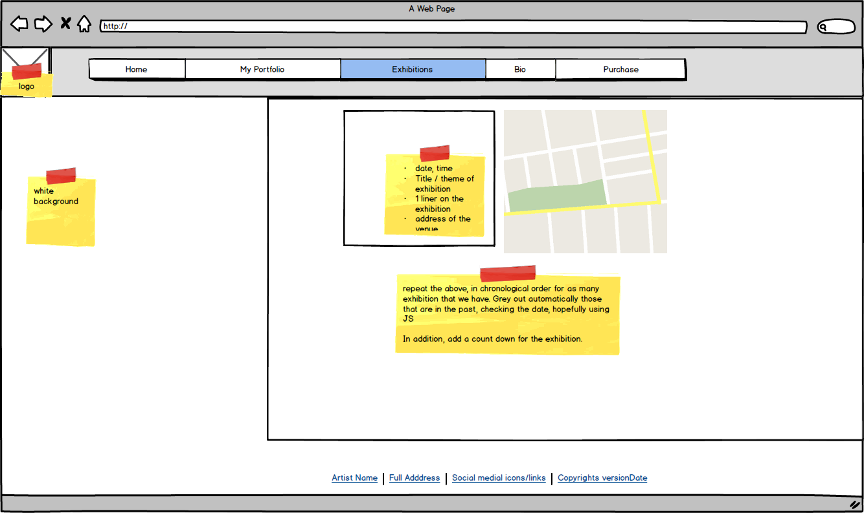

## Biography Page

Display client background information. Include academic achievements and career milestones. Establish the context and inspiration for the client's work. Embellish with carefully chosen self-portraits.

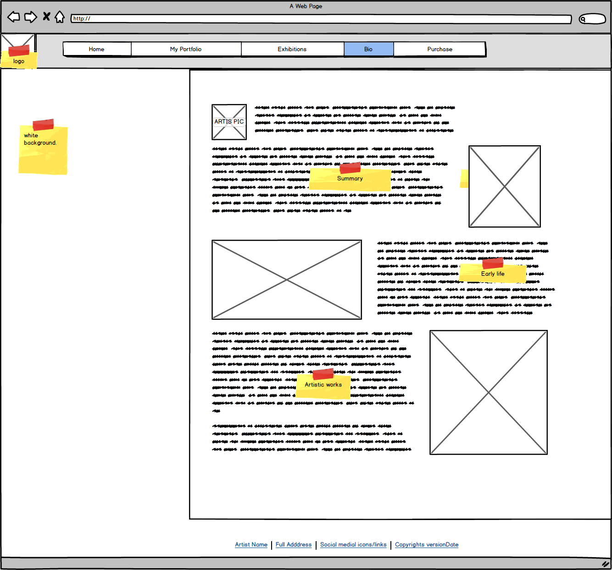

## Purchase Page

Allow clients to request custom art work by submitting a form. Customers can include information like; paints (oil, watercolour), technique, aspect (landscape, portrait).

<Upload a pic> is link to submit image customer to be painted.

Also a photograph of the requested subject can be uploaded. Once all details are filled in and uploaded and email is sent to the client with all the information.

The form will also output a rough quote based on some of the details provide.

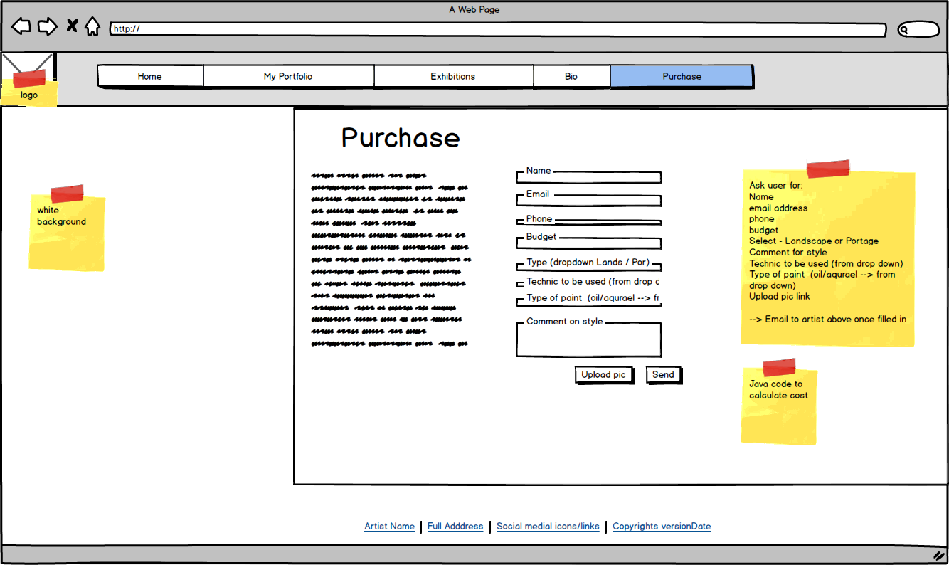

**\*\*\*\*\*\* The following sections should NOT be completed until you have FINISHED your website \*\*\*\*\*\***

# Section 2: Development

# PRODUCTION LOG

** This section should outline how you went about developing your webpage, i.e. HTML, CSS, JavaScript. This should include information on requirements implementation, code development and technical details, such as errors or development issues and how you fixed these.

**Please note:** Make sure to include explanation (**as well as** comments in the HTML files) of any & all code that was taken from the web, or you will **not** receive marks for this third party code. **

We used a central CSS file for all the pages. This is to ensure a centralised repository for all style choises and have the pages be similar in visual outlook. This caused GitHub update errors, as multiple people were updating the file at the same time. Issues where fixed in short order, but using a central CSS might not have been as good a solution as using a central CSS and child CSS files.

All the pages have the exact same headers and footers to make sure Users experience is the same across all the pages. This was one of the first things created and worked well. Originally the plan was to have them in a separate page, but due to time constraints this was simplified as copy-pasting the same cody to each HTML page. In the future versions of the site, it would make sense to modify this approach as current solution is at risk if a page is updated incorrectly.

We tested our site on both Firefox and Safari with no issues seen. As we used standard code, this was not surprising.





We tested our code in Mac and Linux and we did see an issue with showing pictures in bio-page. After testing further the issue seems to have been caused by

<Images/BIO/> when actual path is <images/bio/>. The code section is below and was corrected before taking site to production.



## Interesting code

### Picture gallery – thumbnails to main picture on mouseover







Above code allows User to move mouse over thumbnails, and this will change the main picture to correspond with the chosen one. The basis of the code was found in Javascript - onmouseover not working on chrome (see reference for details) and modified to work correctly. How it works is that on mouse over it will change the file path to correspond with the path to that specific one.

### Exhibition – Using google API to show maps





Above code allows site to use the GoogleMap API. The basis of the code was found in Google Developers (see reference for details) and modified to work correctly. With the code users can find where the exhibitions are.

### Index –Random picture slideshow





Above code allows index page to show random picture on a slide show to users. The basis of the code was found DaniWeb (see reference for details) and modified to work correctly. It uses Java math packages to randomly array. The code ensures same picture is not selected twice in a row. The delay in milliseconds was added to ensure pictures do not change too quick for the user.

### Footer - Add year to footer





Above code allows site to show current year. The basis of the code was found JavaScript Date Object. 2017. *JavaScript Date Object*. (see reference for details) and modified to work correctly.

### Purchase Form









Above code users to get a quota. Code was created by Raymond and not based on online codes. It does a calculation based on user inputs. As an example a base price for a landscape (40EUR) and based on options user choose (oil paint +20%), price is increased.

**Validation**

** This section should look at validation of the website, were you able to validate the website, were there any errors and if so, how did you go about fixing them. Please include a screenshot(s) of your validation report here **

First versions of our code had multiple typo and code issues. Looking at it now we should have validated multiple times, instead of doing the validation at the end of the project. During validation we uploaded file to validator.w3.org and based on error report correct code line by line.

As an example the simple Bio page started with 79 errors on first validation. At the end of the validation tool was not showing any issues on any of the pages. You can see the screenshots of the tool below.





**Deployment**



** This section should include information on your choice of deployment, as well as the sites URL and a screenshot of the live site **

# PROJECT TEAM

** How did the project team break up the tasks required?

Who did what tasks? Did everyone evenly participate?

Were there any team issues? Etc. **

**Please note:** You will each be asked to individually peer review your team mates privately via Moodle also

Team had multiple meetings to divide the tasks, pages and work. After this was agreed, we went off to individually work on our tasks, and came together each week to confirm our work was aligned. Our tasks where tracked via IBM activities and updated when our parts where completed. At the start the high level tasks were

* Index page – Raymond
* Top and bottom nav bars – Fabian
* My portfolio page – Heino
* Bio page – Heino
* Exchibition page – Fabian
* Purchase page – Ray
* CSS - Fabian
* Report – multiple people

After Fabian dropped out of the course in March, this was re-aligned as following:

* Index page – Raymond
* Top and bottom nav bars – Fabian (completed)
* My portfolio page – Heino
* Bio page – Heino
* Exchibition page – Ray
* Purchase page – Ray
* CSS - Fabian
* Report – Ray

The re-alignment bought to light the importance of writing comments on code, as understanding Fabians code was a challenge without him being present.

There was no major issues and team functioned professionally and well.

# CONCLUSION

** Having finished the project, looking back, how did the project go?

Did you achieve what you set out to do?

Are you happy with the results?

Is there anything you might change if you had more time? Etc. **\*\***

Looking at the end result, we think we achieved most of our objectives. The completed pages are simple, elegant and works as intended. The site works.

During the project the change in team size resulted in a re-evaluation of scope and simplification of design. We looked at the timeframe and resources we had, and simplified the design to ensure completion. This caused us to not complete some additional functionalities that were in the original design brief, as we wanted to ensure a completed site using core abilities above all else. Looking at now this change should have been thought of at the beginning, as it is always likely we would have had less time then expected.

# REFERENCES & APPENDIX

** Make sure to include any third party resources / information / code used here.

Make sure to reference correctly as needed, i.e. Harvard Referencing, or marks will be deducted. **

Coderwall. 2017. How to create an image slider with javascript (Example). [ONLINE] Available at: <https://coderwall.com/p/vsdrug/how-to-create-an-image-slider-with-javascript>. [Accessed 19 April 2017].

DaniWeb. 2017. javascript random image slideshow - Web Development | DaniWeb. [ONLINE] Available at: <https://www.daniweb.com/programming/web-development/threads/296862/javascript-random-image-slideshow>. [Accessed 19 April 2017].

Javascript - Preview an image before it is uploaded - Stack Overflow. 2017. javascript - Preview an image before it is uploaded - Stack Overflow. [ONLINE] Available at: <http://stackoverflow.com/questions/4459379/preview-an-image-before-it-is-uploaded>. [Accessed 19 April 2017].

Javascript - onmouseover not working on chrome? - Stack Overflow. 2017. *javascript - onmouseover not working on chrome? - Stack Overflow*. [ONLINE] Available at: <http://stackoverflow.com/questions/21485580/onmouseover-not-working-on-chrome>. [Accessed 19 April 2017].

JavaScript Date Object. 2017. *JavaScript Date Object*. [ONLINE] Available at: <http://www.cev.washington.edu/lc/CLWEBCLB/jst/js_datetime.html>. [Accessed 19 April 2017].

Free photo: Portrait, Face, Woman, Caucasian - Free Image on Pixabay - 1580290. 2017. Free photo: Portrait, Face, Woman, Caucasian - Free Image on Pixabay - 1580290. [ONLINE] Available at: <https://pixabay.com/en/portrait-face-woman-caucasian-1580290/>. [Accessed 19 April 2017].

Google Developers. 2017. *Info windows  |  Google Maps JavaScript API  |  Google Developers*. [ONLINE] Available at: <https://developers.google.com/maps/documentation/javascript/examples/infowindow-simple>. [Accessed 19 April 2017].

pixabay. 2017. pixabay. [ONLINE] Available at: <http://torange.biz/photo/42/42772/42772-FX-6-0-12-6-8-0.jpg>. [Accessed 19 April 2017].

Multiple pictures. 2017. Wikipedia. [ONLINE] Available at: <https://upload.wikimedia.org/wikipedia/commons/c/c2/Winning_Poster_%285816496517%29.jpg>. [Accessed 19 April 2017].